Proposal to Assess, Conserve and Re-inter the Remains of St Thomas More and to Provide Visual Access to their Location at St Dunstan’s Church, Canterbury

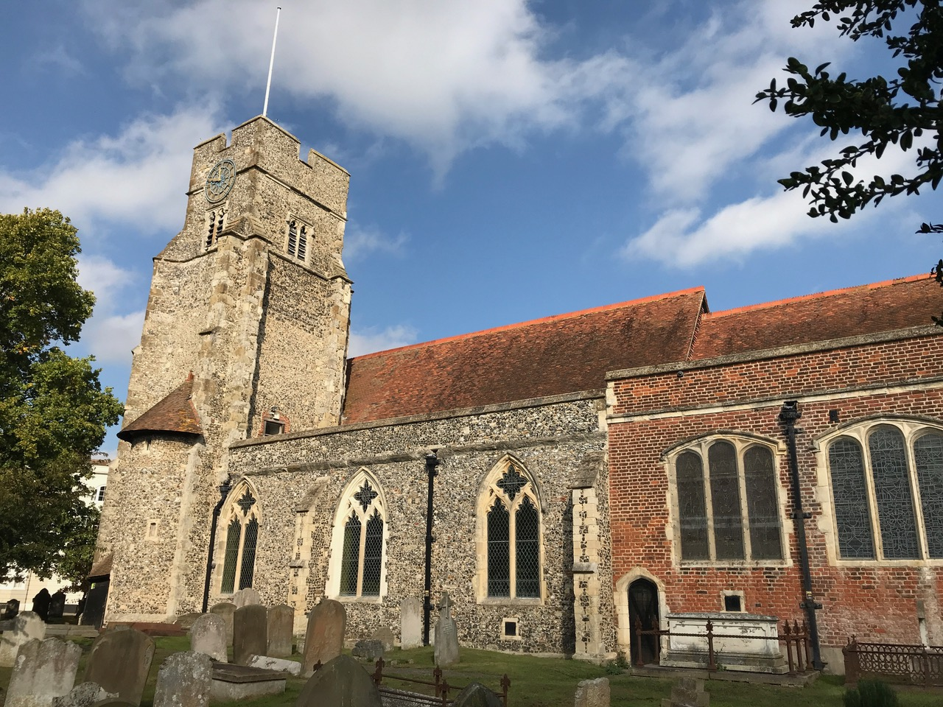

A Call to Action

T
here is an urgent necessity to address and remedy the fact that whatever remains of St Thomas More in the niche of the Roper Vault in St Dunstan’s Church will surely vanish into nothingness and be lost forever if whatever little now remains is not gathered up, properly preserved and reverently encased in an appropriate reliquary before it is too late.

This proposal aims to rectify the situation by proposing that the remains be properly conserved, re-interred and made visible within the vault by means of a glass cover, and that the original lead casket that housed the remains for centuries be placed on secure display in the Roper Chapel.

The Current State of the Remains

In 1978 when the Roper Vault was excavated, it became apparent that vandalism had occurred sometime between the opening of the vault in the 1830s and later in the 19th century when an organ was installed and other work was carried out. That vandalism reduced an identifiable skull to the few fragments that are there today.

This should not be the last word on the subject and left un-remedied.

From the drawing that we have of the niche as it appeared in 1835, showing a recognizable skull within the casket, and given the current state of the casket's contents, it seems reasonable to suspect that sometime during one of the later 19th Century openings of the vault, or at the time of the installation of the organ, or when the vault was partially filled with rubble, the casket's contents were vandalized and/or broken up and some of those contents were removed.

An available forensic report suggests that all that remains of St Thomas More’s head is a part of the hard palette, a piece of the maxilla showing one tooth socket and a fragment of skull, and dust. It must be understood that mere exposure to the air, while the skull remained isolated and undisturbed in its casket and niche, would not have reduced a recognizable skull as it appeared in 1835 to the dust and fragments that remain today.

In the May, 1837 issue of The Gentleman's Magazine there appeared an article written by a correspondent and admirer of St Thomas More. The article was accompanied by the drawing, pictured below, which illustrated what was then, but is no longer, visible of the substantial remains of his skull, and it contained a call to action that echoes here again, over 180 years later, but with a greater resonance than ever before.

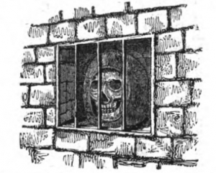

The article reads, in part, as follows:

"In the chancel of... [St. Dunstan's] church is a vault belonging to... [The Roper] family, which, in newly paving of the chancel, in the summer of 1835, was accidentally opened; and, wishing to ascertain whether Sir T. More's scull was really there, I went down into the vault, and found it still remaining in the place where it was seen many years ago, in a niche in the wall, in a leaden box, something of the shape of a bee-hive, open in the front and with an iron grating before it...The wall in the vault, which is on the south side, and in which the scull was found, seems to have been built much later than the time of Sir T. More's decapitation...In musing over these relics of days gone by, and connected as they are— both above and below ground—with that ...pious martyr, I could not but feel that I was treading on religious classic ground, and hope that a similar good feeling might induce some, who venerate the great and the good of other times, to manifest the same laudable wish to save from ruin the sacred walls which contain the head... I enter con amore into restorations of this sort, I have been planning how it might be done with best effect...But the difficulty is, HOW is all this to be accomplished?... I see no other possible way, than some of the descendants of Sir Thomas paying this sacred debt (may I call it?) to the memory of their great and good ancestor, or by others not connected with the family, but who take a deep interest in matters of this sort; doing, in short, as your Magazine records they have lately been doing at Chelsea, and paying the same mark of respect to the head in St. Dunstan’s church, as they have there done to his empty tomb. I have known this church for nearly forty years, and feel a strong wish to see it put into complete order. There is a great capability about it for making it one of the best churches in Canterbury; and I cannot but hope and trust that such may be effected at no distant period; for evidently there seems to be a wish in the parish to improve this sacred edifice; but, alas! their means are inadequate...As I see, from your devoting many pages to accounts of churches and every thing belonging to them worthy of attention, that you interest yourself much in matters of this sort, I hope you will be able to make room, in some early number, for this notice of St. Dunstan's church; and should it be the means of calling the attention of any antiquary to this subject, it will afford much satisfaction to the writer, that he has been in some degree instrumental to the marking more particularly the place where rests the head of one who made no inconsiderable a figure in the history of the reign of the Eighth Henry, and who fell a victim to the jealousy of that tyrant, by so boldly refusing to acknowledge the supremacy of his rule over the Church of England. Yours, &c. V. S. D. “

The call to action in that article was never heeded. The result is that today, instead of seeing what its author described in 1835, as illustrated above, he would see what is revealed in the 1997 photograph below.

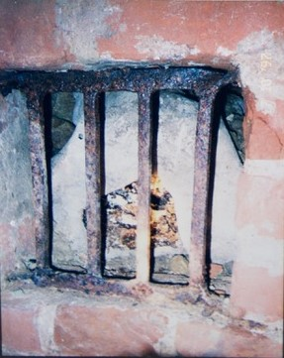

Proposed Next Steps

Although this proposal does not entail placing the remains on display outside the vault, it seems that as with the remains of any historical figure, especially a religious one of the magnitude and significance of and world-wide admiration accorded to St Thomas More, what remains of him should be professionally analyzed, examined, inventoried, documented and photographed.

Once that is done, the remains should be appropriately housed, preserved and protected in a suitable reliquary once and for all, and then restored to the niche in the vault. At the same time, the casket that formerly contained those remains, but which long ago lost any capacity to properly preserve and effectively protect them with the respect to which they are due, should itself be properly preserved and protected by relocating it to a secure site in the Roper Chapel where it may be exhibited to and appreciated by all who may visit the Church, as the significant historical artifact that it represents.

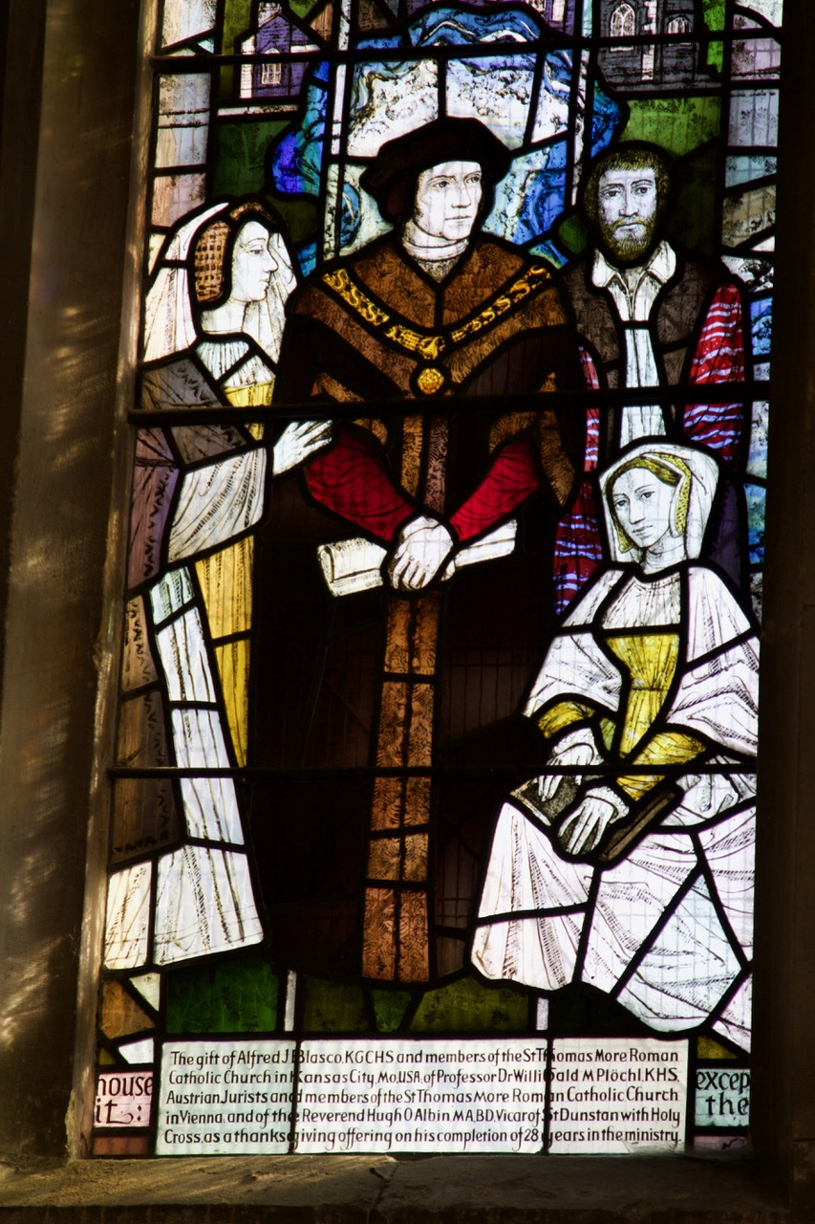 | 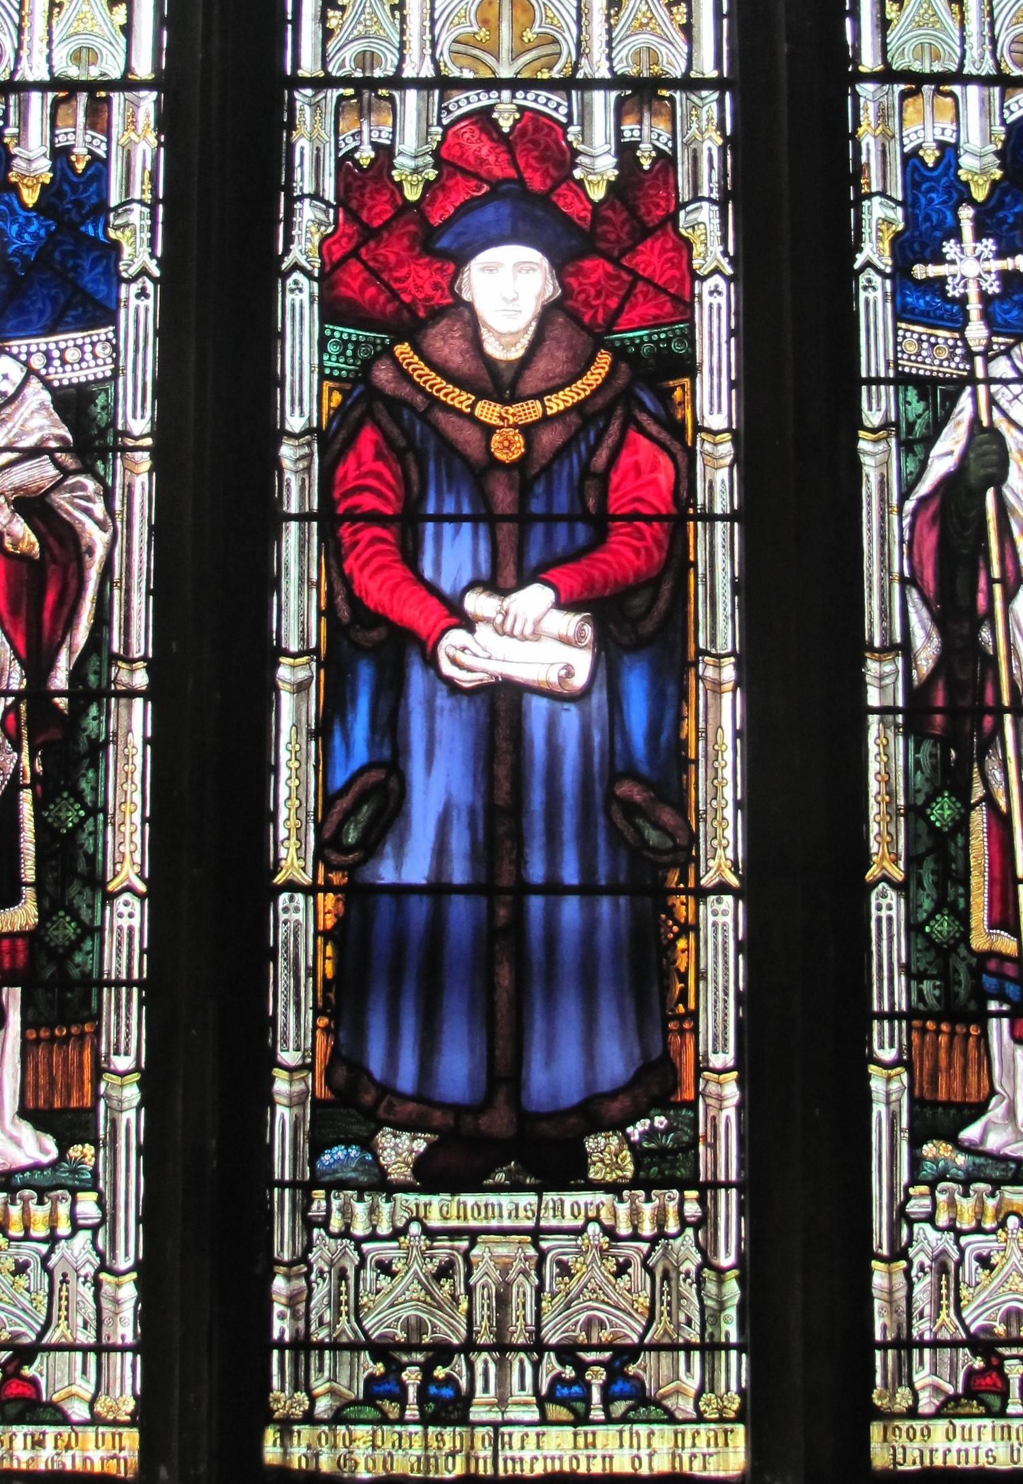

Honouring the More Family’s Wishes

Margaret More Roper courageously salvaged the head of her beloved father from certain destruction when she retrieved it from London Bridge, and she did all that she could to preserve it during her lifetime and beyond. It is not enough for us to recognize and admire what she did, and leave it at that. Instead, we who now, 500 years later, are at last witnessing the potential and irretrievable loss and destruction of what she struggled to preserve, have a duty to ensure that her efforts were not in vain.

This proposal will allow us to do our duty and, once again, retrieve the head of St Thomas More from certain destruction and guarantee its preservation for all time and for all who will forever look to him as a model of courage, intellect and spiritual devotion.
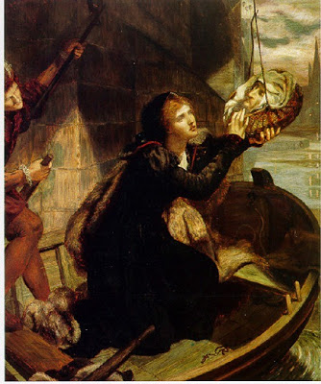
Margaret More Roper retrieving the head of St Thomas More at London Bridge

***

Project Practicalities

Overall Aim:

In light of the above, the proposed ultimate goal is the slight relocation of the memorial slab currently covering the area immediately above the niche in the vault and the installation immediately adjacent to it of a glass slab designed to give perpetual visual access to the niche containing the remains of St Thomas More.

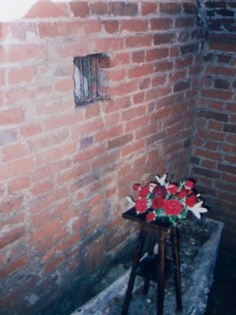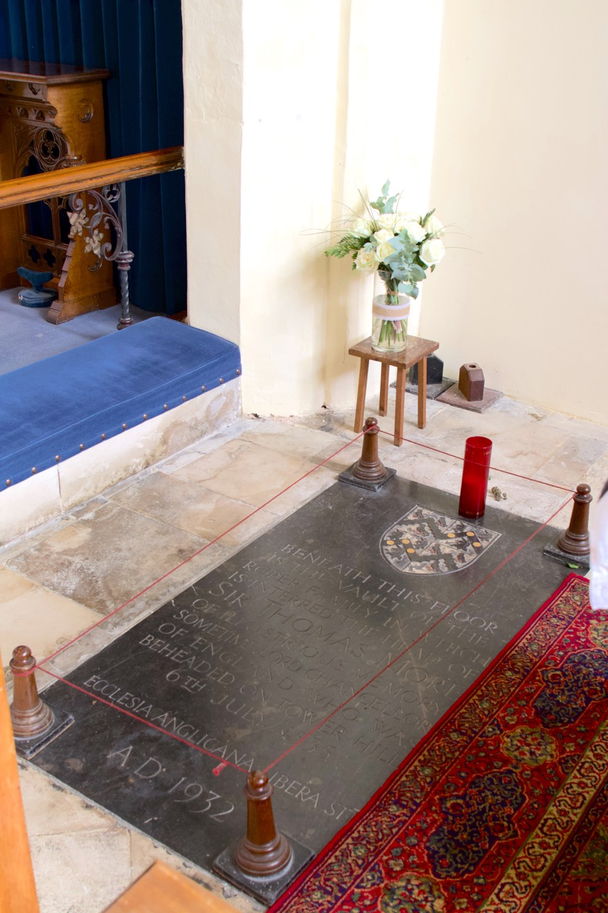
View of the vault and wall niche housing remains Memorial slab currently in position above the vault

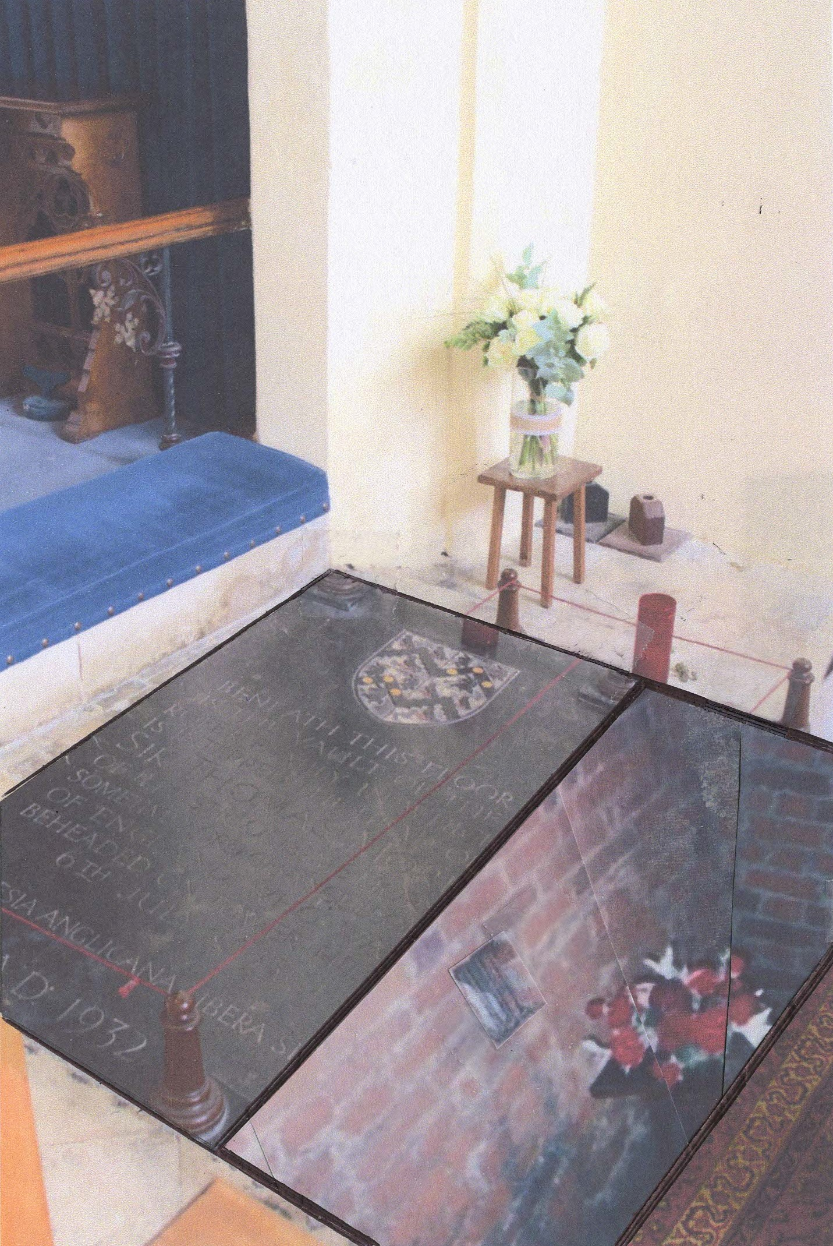
A rendering of the site after relocation of the memorial slab with the glass slab installed adjacent to it giving view to the vault and niche below

Recommended Procedure:

1. Remove the bars to the niche;
2. Photograph, survey and document the niche and its contents, as they now appear;
3. Systematically remove the contents of the lead casket, carefully documenting the location from which each identifiable item is taken from within it;
4. Remove from the lead casket and preserve all other material not otherwise identifiable, after carefully documenting the location from which it is taken from within the casket;
5. Remove the lead casket from the niche;
6. Photograph, survey and document the interior of the empty niche;
7. Systematically remove and preserve the remaining contents of the niche;
8. Have all identifiable remains and other material removed from the lead casket and the niche forensically examined, analyzed, photographed, described and documented;
9. Preserve all identifiable remains and other material removed from the lead casket and the niche;
10. Design and have manufactured a new, secure and air-tight casket, made of gold, bronze, marble or stone, wherein all such identifiable remains and other material removed from the original lead casket may be permanently preserved;
11. Place the new casket containing the remains in the niche;
12. Cover the front of the niche to protect the casket within with a secure door of thick tempered glass, framed in bronze to avoid deterioration;
13. Cover the vault immediately above the niche with a glass slab of the same dimensions of the memorial slab that is currently in place in the floor over the niche that will provide a view of the vault and niche below; and, in addition,
14. Preserve the empty original lead casket in a suitable glass case and allow for its display in the Roper Chapel.
Net Effect of Completing the Above Steps:
1. Margaret Roper's goal of preserving the remains of her father would be respected and furthered;
2. The remains of St Thomas More would be properly and definitively identified, permanently preserved and perpetually protected against further natural deterioration and human interference;
3. The remains would be restored to the niche, but within a proper and secure container/casket;
4. The remains of St Thomas More would no longer rest behind bars in an insecure environment, just as he was condemned to do when imprisoned in the Tower. Instead they would at long last be liberated from that fate and provided with a secure, final resting place suitable for a man of God and of heroic virtue;
5. While the remains would be interred in their original but improved final resting place, preserved and protected in the new casket, the original lead casket could be preserved and made available for viewing for its historical significance in a suitable display case, above ground, in the Roper Chapel.
6. Whilst respectfully and discreetly relegating the remains of St Thomas More to their traditional and long-time place of interment, where they would not be further disturbed, that place of interment would be open to view through the glass floor slab. In addition, the casket that held those remains for so long, but which no longer may be said to be capable of or suitable for so doing, would be visible for all to see who wish to contemplate its role in the story.
Practical and Financial Considerations:

Upon obtaining all of the necessary approvals, it will then be possible to begin the work necessary to establish the organizational, financial and logistical resources that will be needed to bring it into fruition. A first step in that direction would entail the establishment of a non-profit, tax exempt foundation chartered to manage and raise funding for the project. The financing obtained not only would be available to pay for the cost of carrying out this proposal, but it could also provide resources for the continuing maintenance and perpetuation of the site.

